**RECTIFIER INTEGRATIONS**

The highest percentage of rectifiers in the ATC network communicate with RS 485 Modbus protocol.

With the exception of the old Emerson actura optima models and the Delta family, Eltek, Huawei TP48200A and power cube have RS485 enabled ports and communicate to the Galooli Corona units directly.

The delta family, Delta Orion and Delta psc3 give an RS 232 signal which is then converted into an RS 485 signal using the Galooli EX6s extension.

The commonest of the Emerson rectifier is Emerson actura optima.

This has generates alarms with the help an onboard dry contact relay system which then translates the alarm to a particular event.

The relay system has a chronological path.

The first alarm ever that will occur will come from the failure of AC input

1. Mains fail, either generator or grid power, this trigger the relay to open.
2. After a time lag of no restoration the system will assign the active event site is running on battery.
3. Site stays on battery is usually risky if the battery back will drain fast.
4. 4 LVD will be triggered after a while when the voltage thresh holds drop.
5. This will further result in shedding of non-priority loads in order to retain power for the transmission equipment.
6. If no AC returns and the battery voltages drop further down then this equipment shall also shut down when LVP shows on the panel.
7. Beside this relays are system faults and rectifier module fails or rectifier fails, this are as well assigned outputs on the rectifier panel.

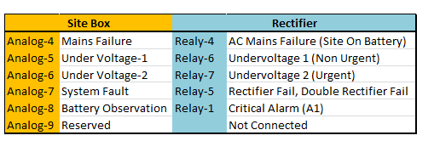

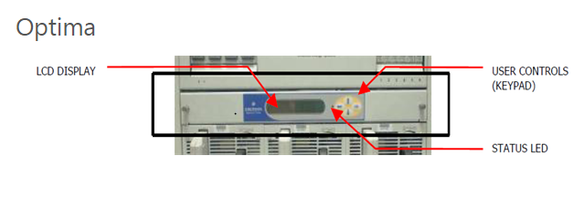



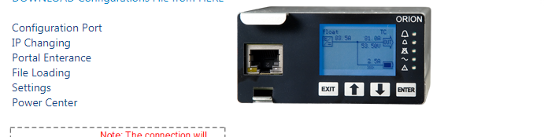

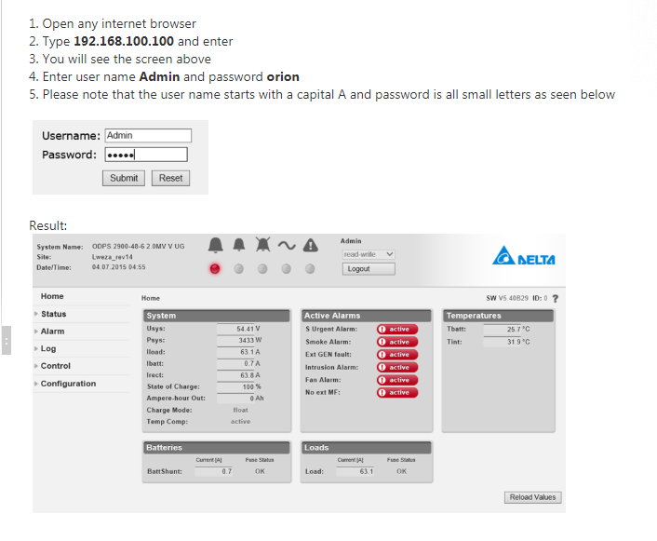

Note the firmware versions and use the latest to achieve the most updated alarm outputs

Huawei TP 48200A, POWER CUBE AND ELTEK RECTIFIERS

This above do not need any conversion of signals to be done.

They have RS 485 enabled ports which we connect to RJ 45 connectors and pick information directly for the system users.

Note all rectifiers communicate on ID’s and a Baudrate.

From above only the Power cube has a different ID setting as below.

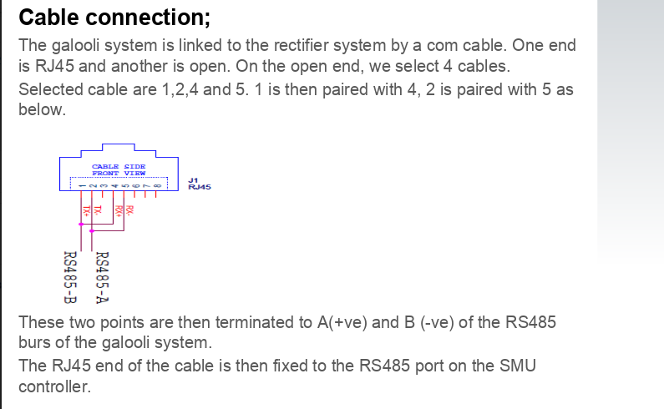

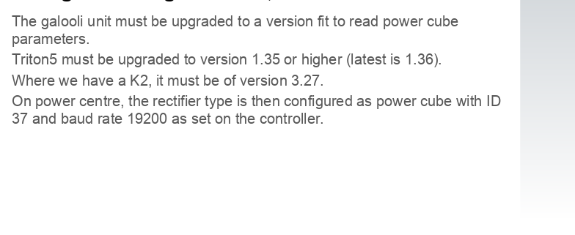

ZTE RECTIFIER

In our work, we have several devices which supports SNMP protocol, and not RS485, which challenging us to read their parameters.

Thus, we have created a unique EX20 ETH, that allows us to query data from a device, using SNMP protocol.

The device is connected to the EX20ETH with Ethernet cable.

The EX20eth is connected to the unit using RS 485 cable/Modbus communication.

The data goes from the EX20ETH to the main unit through the Modbus.

Contrary to configuration with RS485 devices, there is no need to log in the “SNMP Device” panel in order to set its DI/Baudrate…

How to wire and configure?

EX20ETH

EX20ETH has 6 regular inputs+ 3 Ethernet ports. See below picture with wiring instruction:

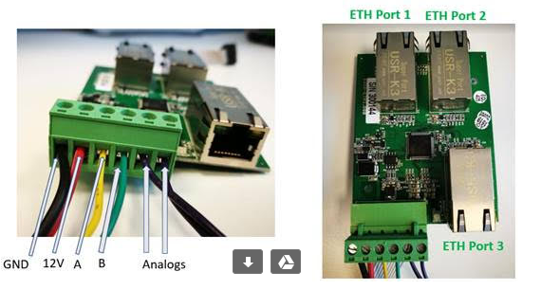

Note: a full wiring diagram will be sent soon.

EX20ETH ID should be 5

In the device’s configuration screen on Power Center, you need to configure the device on the relevant Ethernet port it is connected. On the below example, the device ZTE-ZXDU68 is connected and configured on ETH port no. 1

The device’s ID should be according the regular wiring diagram, for example: rectifier = ID20. (reminder: the ID should not be set inside the rectifier’s panel at all).

If the device is communicating with the EX20, a fast led blink will be seen in the connection point of the rectifier, and you will see “Alive” status in the Power Center.

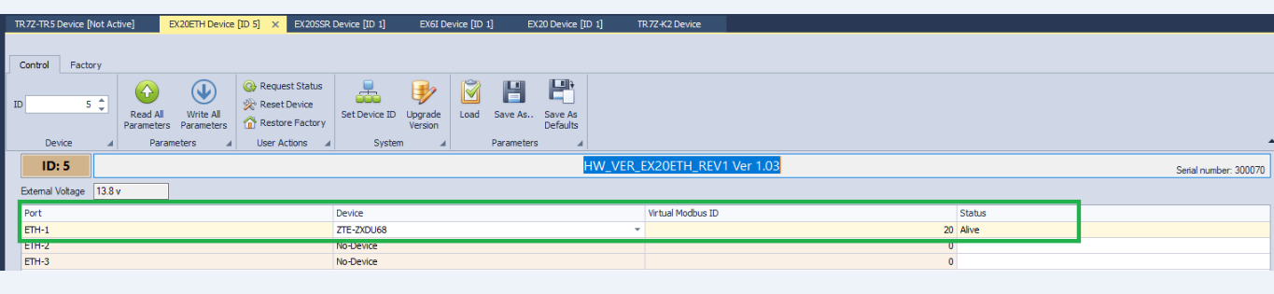

**TR7ZK2**

At the main unit side, it is required to configure both EX20 ETH (ID 5) and the rectifier’s ID ad configured in the EX20 ETH (on the below example- 20)

Data will appear on the Rectifier’s section in the status tab, as usual.

Note: in the example below, with ZTE, we are not reading all the parameters., but a few of them. In any case, it is a must to verifying during any installtion that the values our system reading is match to the parameters in the panel.

